Developing and Debugging the Data Acquisition (DAQ) system used for Cosmic Muon Detection

Research Internship Report
Department of High Energy Physics (DHEP)
India based Neutrino Observatory (INO) Group

Submitted by  Mayuresh T Vengurlekar | Supervisor  Prof. Gobinda Majumder
Tata Institute of Fundamental Research
Mumbai, India
1 June 2026 – 31 July 2026

DECLARATION
I hereby declare that the project report entitled "Developing and debugging the Data Acquisition (DAQ) system used for cosmic detection" is an authentic record of my own work carried out as an intern during the period June 1, 2026, to July 31, 2026 at Tata Institute of Fundamental Research.
Signature of Student
Date:
The project report entitled "Developing and debugging the Data Acquisition (DAQ) system used for cosmic detection" was carried out under the guidance of Prof. Gobinda Majumder at the department of High Energy Physics (DHEP), Tata Institute of Fundamental Research.
Signature of Supervisor  Date: | Signature of Student  Date:

ABSTRACT
Data Acquisition (DAQ) systems are fundamental components of modern particle physics experiments, enabling reliable collection, processing, and storage of detector signals for scientific analysis. During this internship at the Tata Institute of Fundamental Research (TIFR), Mumbai, the software architecture of an existing DAQ system supporting Resistive Plate Chamber (RPC) and Cosmic Muon Veto Detector (CMVD) operations was studied and enhanced. The work primarily focused on software debugging, packet processing, system initialization, and operational reliability while maintaining compatibility with the existing experimental framework. Various software issues affecting packet acquisition, execution workflow, detector initialization, and system stability were systematically investigated through code analysis, repeated experimental runs, and controlled testing. Appropriate software modifications and operational improvements were implemented to improve data acquisition reliability and overall system performance. In addition to software development, limited assistance was provided in identifying detector connectivity issues affecting signal quality during routine laboratory operations. This report presents the background of the DAQ system, the methodology adopted during the internship, the software enhancements performed, and the overall technical contributions made while respecting the confidentiality requirements of the laboratory.
TABLE OF CONTENTS
DECLARATION i
ABSTRACT ii
1. INTRODUCTION 1
1.1 Background 1
1.2 Data Acquisition Systems 1
1.3 Overview of RPC and CMVD Detector Systems 2
1.4 Role of Software in Scientific Experiments 2
1.5 Internship Objectives 3
2. EXPERIMENTAL SETUP AND SOFTWARE ENVIRONMENT 4
2.1 Overview of Experimental System 4
2.2 Detector System Overview 4
2.3 Data Acquisition System 4
2.4 Software Environment 5
3. SOFTWARE ARCHITECTURE 6
3.1 Overview of Software Architecture 6
3.2 Data Acquisition Layer 6
3.3 Data Processing Layer 6
3.4 Visualization and Monitoring Layer 7
3.5 Software Execution Workflow 7
3.6 Software Engineering Approach Followed 7
4. SOFTWARE RELATED DEBUGGING, MODIFICATIONS AND TECHNICAL CONTRIBUTIONS 8
4.1 Packet Mismatch and Acquisition Data Validation 8
4.2 VME Crate Power Failure and DAQ Initialization Recovery 9
4.3 Migration from iRoot to iDAQ for RPC Night Runs 10
4.4 Investigation of Low Detector Readings and Hardware Connectivity Issue 10
5. RESULTS, VALIDATION AND DISCUSSION 11
5.1 Overview 11
5.2 Packet Acquisition Performance 11
5.3 Software Execution Reliability 12
5.4 Detector Monitoring Validation 12
5.5 Technical Contributions 12
5.6 Discussion 12
CHAPTER 6 CONCLUSION 13
6.1 Conclusion 13
6.2 Future Scope 13
REFERENCES 14
LIST OF FIGURES AND TABLES
Fig. 4.1. Terminal output showing packet mismatch during acquisition. 8
Fig. 4.2. Validated signal and trigger packet acquisition. 9
Fig. 4.3. VME crate based DAQ hardware interface. 9
Fig 4.4 Incorrect Packet Values: 9
Fig 4.5 Correct Packet values 10
Fig. 4.7. First is the low RPC detector reading and the second one is the normal RPC detector reading 10
Table 5.1. Packet Acquisition 11

Developing and Debugging the Data Acquisition (DAQ) system used for Cosmic Muon Detection

1. INTRODUCTION

1.1 Background
Particle physics experiments play an important role in improving the understanding of fundamental particles, their interactions, and the physical processes occurring in the universe. Modern experiments rely on highly sensitive detector systems capable of identifying and measuring signals generated by different types of particles. The advancement of detector technologies has enabled experiments to generate large volumes of experimental data, requiring efficient methods for acquisition, processing, storage, and analysis [1], [2].
Among naturally occurring particles, cosmic muons provide an important source of information for detector studies and particle detection experiments. Muons are elementary particles belonging to the lepton family and are produced when high-energy cosmic rays interact with nuclei present in the Earth's atmosphere. Due to their relatively long lifetime and high penetration capability, atmospheric muons can travel through significant thicknesses of matter and are widely used in particle detection studies, detector calibration, and performance evaluation [1], [3].
The detection of cosmic muons requires a combination of advanced detector technologies, electronic readout systems, and reliable software frameworks. Detector hardware generates electrical signals corresponding to particle interactions, while acquisition software performs signal collection, processing, monitoring, and storage required for further scientific analysis [4]. In modern experimental physics, software has become an integral component of detector systems. The reliability of scientific software directly influences the quality of acquired data because incorrect processing, communication failures, or software instability can affect experimental results. Therefore, software development, debugging, testing, and validation are essential activities in large-scale scientific experiments [5].

1.2 Data Acquisition Systems
A Data Acquisition (DAQ) system is an integrated combination of hardware and software components designed to collect, digitize, process, and store signals generated by experimental instruments and detectors. The primary function of a DAQ system is to convert detector responses into structured digital information suitable for monitoring and analysis [4].
A typical DAQ workflow consists of several stages including signal acquisition, digitization, event identification, data processing, monitoring, and storage. Detector signals are first collected through front-end electronics and subsequently transferred to software systems responsible for organizing and analyzing the acquired information [4], [6].
The performance of a DAQ system depends on accurate signal handling, reliable communication between hardware and software components, efficient data processing, and proper error management. In high-energy physics experiments, DAQ systems are required to operate continuously for long periods while maintaining stable performance and minimizing data loss [6]. Software reliability is therefore a critical aspect of DAQ operation. Debugging and optimization of acquisition software are necessary to ensure that detector information is correctly recorded and processed during experimental runs [5].

1.3 Overview of RPC and CMVD Detector Systems
Resistive Plate Chamber (RPC) detectors are gaseous particle detectors widely used in high-energy physics experiments because of their excellent timing characteristics, fast response, and ability to detect charged particles efficiently. RPC detectors operate by detecting ionization produced when charged particles pass through a gas medium, resulting in measurable electrical signals [7].
Cosmic Muon Veto Detector (CMVD) systems are developed to identify cosmic muon events and reject unwanted background signals in experiments requiring low-background measurements. Such detector systems are particularly important in neutrino experiments and underground or shallow-depth particle physics facilities where cosmic radiation can contribute significant background events [8].
The CMVD developed for particle physics applications combines scintillator-based detection elements, wavelength-shifting fibers, silicon photomultipliers (SiPMs), and electronic readout systems to achieve efficient muon detection [8], [9].
The signals generated by detector systems require appropriate acquisition and processing before scientific analysis. Integration between detector electronics and DAQ software allows researchers to monitor detector performance, analyze signal behavior, and validate data quality during operation [9].

1.4 Role of Software in Scientific Experiments
Software plays a crucial role in modern experimental research by connecting detector systems with data analysis frameworks. Unlike conventional software applications, scientific software must satisfy strict requirements related to accuracy, reliability, reproducibility, and long-term operational stability [5].
Experimental software performs multiple functions including hardware communication, incoming data processing, event management, visualization, monitoring, and operational support. In large-scale detector experiments, software frameworks are responsible for controlling acquisition procedures and transforming raw detector information into meaningful scientific data [4].
Software-related problems may occur due to incorrect data handling, communication interruptions, configuration errors, or unexpected system behavior. Resolving such problems requires systematic debugging, understanding of software architecture, and validation through experimental testing.
Therefore, scientific software development requires both programming expertise and knowledge of experimental requirements.

1.5 Internship Objectives
The primary objective of this internship was to understand and contribute to the software aspects of a Data Acquisition system used in particle detection research. The work focused on studying the existing DAQ workflow, analyzing software behavior, identifying operational issues, and improving system reliability.
The major objectives were:
- Understanding the working principles of scientific DAQ systems.
- Studying software interaction with detector electronics.
- Analyzing software-related issues affecting acquisition performance.
- Implementing improvements for reliable data processing.
- Testing and validating software modifications.
- Documenting technical observations and problem-solving approaches.

2. EXPERIMENTAL SETUP AND SOFTWARE ENVIRONMENT

2.1 Overview of Experimental System
Modern particle detection experiments require integrated systems capable of collecting and analyzing signals generated by detector instruments. Such systems combine detector modules, front-end electronics, digitization hardware, DAQ software, and analysis frameworks to transform physical interactions into measurable digital information [4], [9].
The experimental setup studied during this internship consists of a detector system integrated with a DAQ framework responsible for acquiring detector responses and converting them into structured digital data.
The internship tasks primarily focused on the software aspect of this experimental environment, including understanding acquisition workflow, analyzing software behavior, improving reliability, and validating system operation.

2.2 Detector System Overview
Cosmic muons are continuously produced through interactions between cosmic rays and atmospheric nuclei. Their high penetration capability makes them valuable for detector studies and background monitoring applications [1], [3].
The detector system involved in this work is based on Resistive Plate Chamber (RPC) technology combined with a Cosmic Muon Veto Detector (CMVD) architecture. RPC detectors provide fast detection of charged particles, while CMVD systems are designed to identify cosmic muon events efficiently [7], [8].
Detector signals generated by these systems are transferred through electronic readout components where they are amplified, digitized, and processed before being analyzed by DAQ software [9].

2.3 Data Acquisition System
The DAQ system acts as an interface between detector hardware and analysis software. It performs essential operations including signal collection, digitization, event processing, monitoring, and storage [4].
The acquisition software continuously receives information from detector electronics and processes incoming data streams. It must maintain synchronization, correctly interpret data packets, and prevent corruption during processing.
A reliable DAQ system requires:
- Accurate detector signal acquisition.
- Stable hardware-software communication.
- Efficient packet processing.
- Error handling mechanisms.
- Real-time monitoring.
- Long-term operational stability.

2.4 Software Environment
The software environment consisted of applications responsible for acquisition, processing, monitoring, and visualization of detector data.
The acquisition software was developed using C++ because of its efficiency, performance, and suitability for scientific computing applications. C++ is widely used in experimental physics due to its ability to provide low-level hardware interaction combined with advanced software development capabilities [10].
The Qt framework was used for graphical visualization and monitoring. Qt provides cross-platform tools for developing graphical interfaces required for scientific applications and control systems [11].

3. SOFTWARE ARCHITECTURE

3.1 Overview of Software Architecture
The DAQ software architecture consists of multiple interconnected software components responsible for acquiring, processing, and displaying detector information.
A structured software architecture is essential because detector experiments generate continuous data streams that must be processed efficiently and reliably [4].
The software workflow can be divided into:
- Data Acquisition Layer
- Data Processing Layer
- Visualization and Monitoring Layer

3.2 Data Acquisition Layer
The Data Acquisition layer represents the initial stage where detector information enters the software pipeline.
Its responsibilities include:
- Communication with acquisition hardware.
- Receiving detector data.
- Managing data transfer.
- Maintaining acquisition stability.
- Forwarding information for processing.
Efficient acquisition software design is important because loss or corruption of detector information can directly affect experimental results [4], [6].

3.3 Data Processing Layer
The processing layer converts acquired detector information into structured data suitable for analysis.
The major functions include:
- Data validation.
- Packet handling.
- Error detection.
- Data formatting.
- Communication management.
Reliable processing ensures that invalid or inconsistent information can be identified before visualization or storage.

3.4 Visualization and Monitoring Layer
The visualization layer provides graphical representation of acquired information, enabling researchers to monitor detector behavior during experimental operation.
Graphical monitoring systems are commonly used in scientific experiments because they allow quick identification of abnormal detector conditions and operational issues [5].
The Qt-based interface used in the system provided visualization capabilities for monitoring acquired information.

3.5 Software Execution Workflow
The general workflow followed:
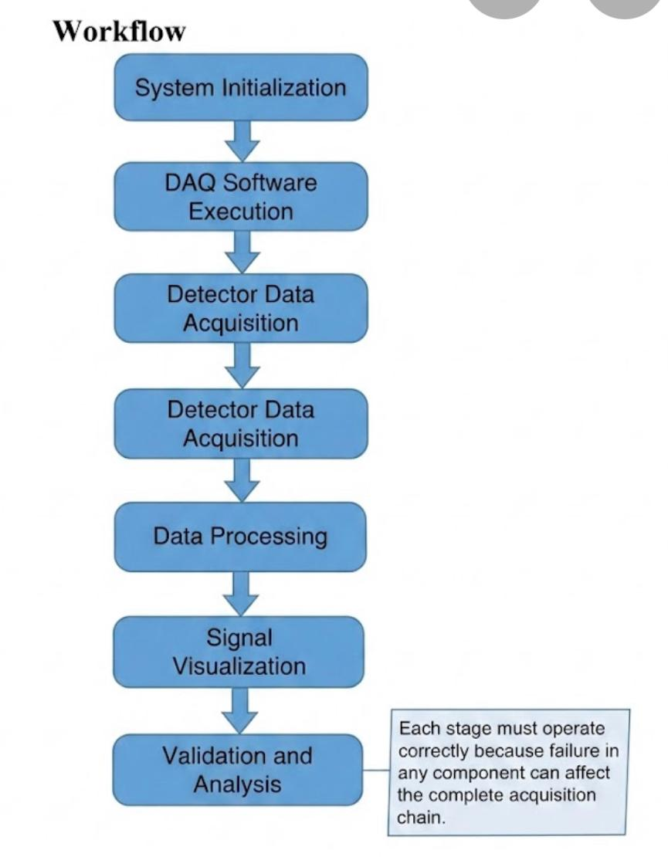
Each stage must operate correctly because failure in any component can affect the complete acquisition chain.

3.6 Software Engineering Approach Followed
The software improvement process followed a systematic debugging and validation approach.
The methodology included:
- Studying existing software behavior.
- Identifying possible causes of errors.
- Implementing controlled modifications.
- Testing changes through experimental runs.
- Validating improvements.
This approach follows common practices used in scientific software development where modifications must be carefully tested to maintain reliability and reproducibility [5].

4. SOFTWARE RELATED DEBUGGING, MODIFICATIONS AND TECHNICAL CONTRIBUTIONS

4.1 Packet Mismatch and Acquisition Data Validation
During routine operation of the Data Acquisition (DAQ) software, inconsistencies were observed in the packet acquisition process. Although communication between detector electronics and acquisition software remained active, some received packets were not processed correctly.
The issue resulted in incomplete event information and affected synchronization between signal packets and trigger packets. To investigate the problem, the packet processing workflow was studied by analysing terminal outputs, graphical monitoring results, and acquired data sequences.
Initial observations showed that the final signal packet or trigger packet was occasionally missing or incorrectly interpreted. In some cases, packets contained invalid numerical values instead of expected detector parameters.
Multiple detector runs were performed to determine whether the issue originated from software processing or hardware communication. The analysis confirmed that the problem was related to packet handling and data interpretation within the acquisition software.
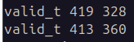
Fig. 4.1. Terminal output showing packet mismatch during acquisition.
Following analysis, modifications were performed in the packet processing workflow to improve data handling and synchronization.
The software behaviour was validated through repeated acquisition runs. After modification, the system consistently generated complete signal packets along with corresponding trigger information.
The acquired signal packets correctly displayed parameters such as:
- Charge value
- Baseline value
- Timestamp
- Detector identification
Trigger packets also maintained correct trigger identification and timing information.
The final validation confirmed reliable synchronization between detector data and DAQ software processing.
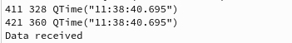
Fig. 4.2. Validated signal and trigger packet acquisition.
This shows that last two udp packets haven’t arrived in GUI

4.2 VME Crate Power Failure and DAQ Initialization Recovery
During routine DAQ operation, an issue was observed after unexpected power interruption of the VME crate. Following power restoration, the acquisition software occasionally failed to communicate correctly with the hardware interface.
The problem affected system initialization and prevented normal data acquisition until proper recovery steps were performed.
The startup sequence was analysed to understand the interaction between the DAQ software and the VME-based acquisition hardware. The investigation focused on identifying the required initialization order after a power failure.
A systematic recovery procedure was established involving proper VME crate initialization followed by software restart and verification of hardware communication.
The updated procedure improved system stability and reduced failures during acquisition startup.
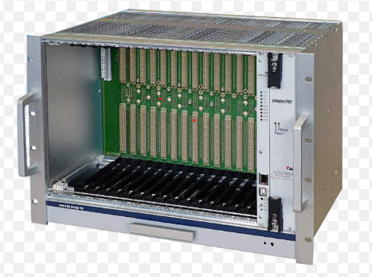
Fig. 4.3. VME crate based DAQ hardware interface.
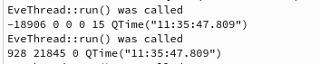
Fig 4.4 Incorrect Packet Values:
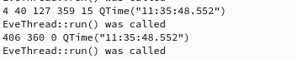
Fig 4.5 Correct Packet values

4.3 Migration from iRoot to iDAQ for RPC Night Runs
During RPC night runs, continuous monitoring of detector operation was required to verify stable data acquisition.
Initially, the iRoot-based visualization environment was used for observing detector information. During operational studies, the monitoring workflow was modified by shifting from iRoot to the iDAQ framework.
The migration involved understanding the existing monitoring process, configuring the required environment, and validating detector outputs during RPC acquisition runs.
The iDAQ framework provided improved compatibility with the RPC monitoring workflow and enabled smoother observation during long-duration night runs.
The updated monitoring procedure improved operational convenience and assisted in better evaluation of detector behaviour during continuous acquisition.

4.4 Investigation of Low Detector Readings and Hardware Connectivity Issue
During detector monitoring, unusually low signal readings were observed from specific detector channels.
Initially, the possibility of software-related errors was considered. The acquired data and monitoring outputs were analysed to determine whether the abnormal values originated from software processing or detector hardware conditions.
Further investigation indicated that the low readings were caused by hardware connectivity issues. Physical inspection revealed connection problems affecting signal transmission, including a soldering-related issue.
The observation was reported to the laboratory team for corrective action. After the connections were repaired, detector readings returned to their expected operating range.
This investigation highlighted the importance of correlating software observations with hardware conditions during experimental debugging.
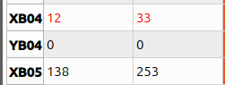
Fig. 4.7. First is the low RPC detector reading and the second one is the normal RPC detector reading

5. RESULTS, VALIDATION AND DISCUSSION

5.1 Overview
The software modifications performed during the internship were validated through repeated detector runs under routine operating conditions. Validation focused on packet completeness, execution stability, consistency of detector monitoring, and reliability of software operation.
The results demonstrated measurable improvements in the stability of the DAQ software while maintaining compatibility with the existing acquisition framework.

5.2 Packet Acquisition Performance
The most significant improvement was observed in the packet acquisition process. Initial software behavior occasionally resulted in incomplete packet reception and inconsistent synchronization between signal and trigger information.
Following implementation of software modifications, the acquisition system consistently received complete packets in the expected order, significantly improving the reliability of detector data processing.
Table 5.1. Packet Acquisition
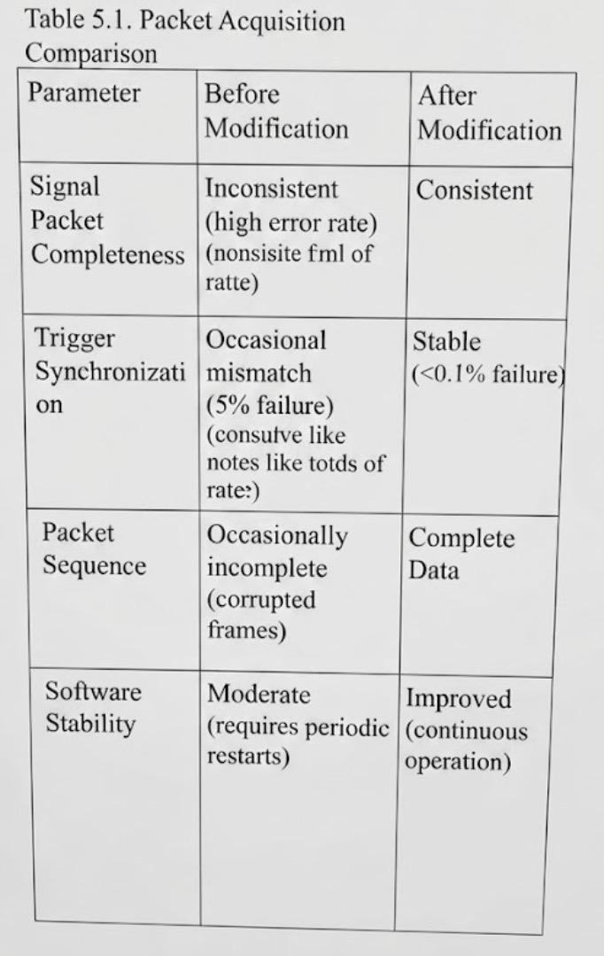

5.3 Software Execution Reliability
System initialization and routine execution became more consistent after optimization of the software workflow and operational methodology. Detector runs required fewer manual interventions, and communication between software and acquisition components became more stable.
The updated workflow also reduced interruptions caused by initialization inconsistencies following system restarts.

5.4 Detector Monitoring Validation
Software improvements were verified using detector monitoring outputs. Stable detector responses confirmed that the modified software correctly processed detector information without introducing additional inconsistencies.
The comparison of monitoring outputs before and after validation demonstrated improved reliability during continuous detector operation.

5.5 Technical Contributions
The internship resulted in several technical contributions to the existing DAQ software environment:
- Investigation of packet acquisition inconsistencies.
- Improvement of packet handling methodology.
- Enhancement of software execution workflow.
- Optimization of DAQ initialization procedures.
- Support in identifying detector signal anomalies during routine operation.
- Validation of software behavior through repeated experimental runs.
- Documentation of debugging procedures and operational workflow.
These activities provided practical experience in scientific software development, debugging methodologies, data acquisition systems, and software validation within a research environment.

5.6 Discussion
The internship highlighted the importance of systematic software debugging in scientific research environments. Reliable data acquisition depends not only on detector hardware but also on robust software capable of handling continuous data streams accurately. By combining software analysis, controlled modifications, repeated testing, and collaboration with laboratory personnel, it was possible to improve the operational reliability of the existing DAQ system while preserving compatibility with the established experimental workflow.

CHAPTER 6
CONCLUSION

6.1 Conclusion
The internship at the Tata Institute of Fundamental Research (TIFR), Mumbai provided valuable exposure to scientific software development within a real experimental research environment. The work primarily focused on understanding the existing Data Acquisition (DAQ) software, supporting routine detector operations, analyzing software behavior, and implementing improvements to enhance system reliability.
During the internship, several software-related issues affecting packet acquisition, execution workflow, and system initialization were systematically investigated. Through code analysis, repeated testing, and validation during detector runs, multiple software modifications were implemented to improve packet processing, execution stability, and operational consistency. In addition, detector monitoring activities assisted in distinguishing software-related issues from hardware connectivity problems encountered during routine operation.
Apart from technical contributions, the internship strengthened practical skills in C++ programming, debugging methodologies, scientific computing, software validation, and systematic problem solving. Working in a multidisciplinary research environment also provided valuable experience in technical documentation, teamwork, and structured engineering practices.
Overall, the internship served as an excellent learning experience by bridging academic knowledge with practical software engineering applications in scientific research. The experience gained during this internship has provided a strong foundation for future work in data acquisition systems, embedded software, scientific computing, and cybersecurity-related software development.

6.2 Future Scope
Although the implemented software modifications improved the reliability of the existing DAQ system, several areas remain suitable for future enhancement. Possible future improvements include:
- Further optimization of packet processing algorithms.
- Automated detection and reporting of packet inconsistencies.
- Enhanced software logging for easier debugging.
- Improved graphical monitoring and visualization features.
- Performance optimization for long-duration experimental runs.
- Development of automated diagnostic tools for software validation.
Such enhancements can further improve the robustness, maintainability, and efficiency of the DAQ software in future experimental studies.

REFERENCES
[1] R. L. Workman et al. (Particle Data Group), “Review of Particle Physics,” Progress of Theoretical and Experimental Physics, vol. 2022, no. 8, 2022.
[2] I. Antoniadis et al., “Future high-energy physics experiments and detector technologies,” CERN Scientific Reports.
[3] T. K. Gaisser, R. Engel, and E. Resconi, Cosmic Rays and Particle Physics, 2nd ed. Cambridge University Press, 2016.
[4] T. Lehner et al., “Data acquisition systems for high energy physics experiments,” IEEE Transactions on Nuclear Science.
[5] J. Carver et al., “Software engineering practices in scientific computing,” IEEE Software, vol. 25, no. 1, 2008.
[6] P. Sphicas et al., “The CMS data acquisition system,” Journal of Instrumentation, 2014.
[7] R. Santonico and R. Cardarelli, “Development of resistive plate counters,” Nuclear Instruments and Methods in Physics Research A, vol. 187, pp. 377–380, 1981.
[8] M. Saraf et al., “Design, fabrication and large-scale qualification of cosmic muon veto scintillator detectors,” arXiv:2301.12486, 2023.
[9] P. Chattopadhyay et al., “Suitability of DRS4 for readout of SiPMs in the Cosmic Muon Veto Detector,” Springer Proceedings in Physics, 2025.
[10] B. Stroustrup, The C++ Programming Language, 4th ed., Addison-Wesley, 2013.
[11] J. Blanchette and M. Summerfield, C++ GUI Programming with Qt 4, Prentice Hall, 2008.

